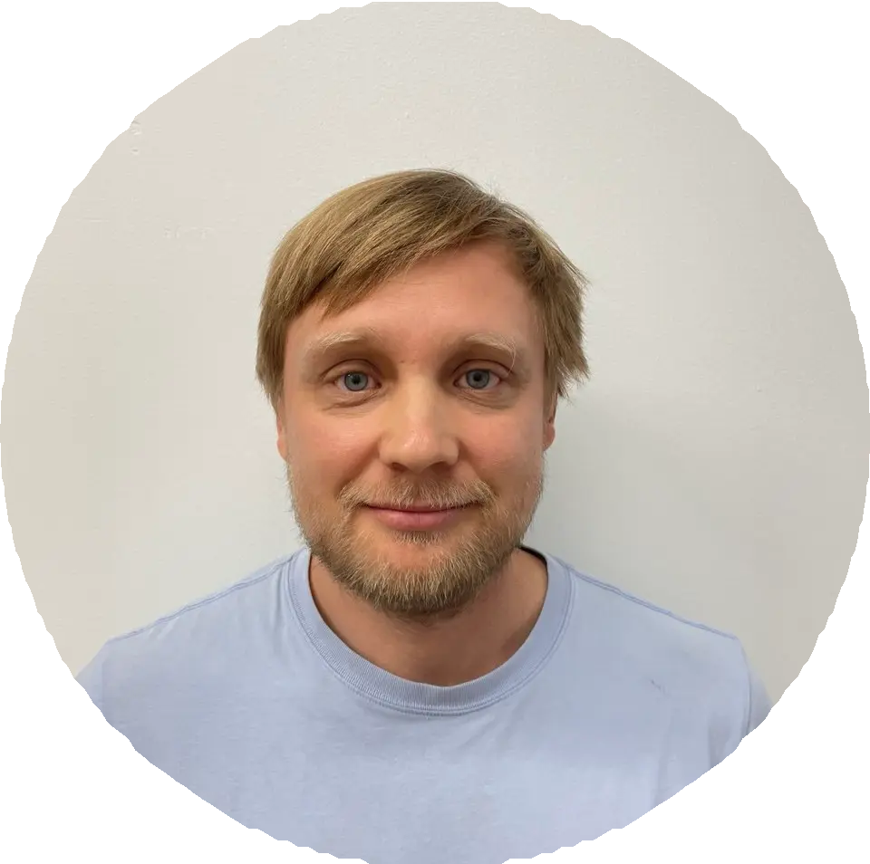
Kon stan tin Zhdan ov
Software Engineer

pinchv@gmail.com linkedin.com/in/kzhdan
telegram/@jimmy_pop_mc

About

Full-stack Software Engineer with 10+ years of experience building and scaling SaaS platforms. Proven expertise in leading frontend teams, modernizing legacy systems, and implementing AI-driven document automation. Strong background in JavaScript/TypeScript, React, Node.js, and cloud-based CI/CD workflows.

Skills
JavaScript TypeScript React Redux Redux-Saga Node.js Webpack Jest React Testing Library Playwright C# ASP.NET MVC Storybook AWS GitHub actions Expo React Native Next.js
Prisma ORM Tailwind CSS / SASS Grafana Sentry Kibana Git Sql Jira Agile PDF.js
Experien ce · 15 yrs

airSlate
Full-time · 3 yrs Hybrid

Senior Software Engineer, Team Lead
Mar 2023 - Present
Boston, Massachusetts, United States
- Worked in the "core" editor's teams as senior software engineer and finally team lead in SignNow;
- Scaled SignNow revenue from $4M → $45M ARR through improved UX and new features;
- Led a frontend team of 9 engineers developing the core document editor (React, PDF.js);
- Implemented "shift left" approach to developing, implemented PW integration testing for the product, reducing manual QA load by 60%;
- Built an AI assistant to summarize uploaded documents using openAI APIs;
- Automated product localization into 10+ languages (AI + Crowdin);
- Migrated the legacy Angular 1.5 codebase to modern React/TypeScript;
- Implemented CI/CD pipelines via GitHub Actions.

airSlate
Full-time · 4 yrs 9 mos Hybrid

Senior Frontend Engineer
Jul 2018 - Mar 2023
St Petersburg City, Russia

- Introduced Sentry and Grafana monitoring boards to identify and fix user issues early, significantly boosting customer satisfaction, product ratings, and retention;
- Built and deployed an A/B testing system that clarified business decision-making and boosted confidence in product hypotheses;
- Ensure accessibility compliance with ADA (Americans with Disabilities Act) and WCAG AAA standards, enhancing usability for disabled customers;
- Designed and implemented core document creation and editing capabilities, enabling advanced page management and PDF content modification;
- Implemented a formula and dependency engine for documents, enabling calculated fields and dynamic visibility through graph traversal;
- Automated product localization into 10+ languages (AI + Crowdin);
- Added functionality to group multiple documents together, enhancing document organization.

BIARUM
Full-time · 1 yr 5 mos Hybrid

Senior Frontend Developer
Feb 2017 - Jun 2018
St Petersburg City, Russia
- Developed data visualization and geolocation-based analytics tools for US clients;
- Worked on projects related to traffic information platforms;
- Later transitioned to work on the PDFFiller project, which led to joining airSlate;
- Migrate web app PdfFiller from Adobe Flash to React.js.

Credin form In formation Agen cy
Full-time · 1 yr 11 mos On-site

Full Stack Developer
Apr 2015 - Feb 2017
St Petersburg City, Russia

- Contributed to the Globas information system;
- Migrated core application stack from Backbone.js/jQuery to React.

C.Nord Ltd.
Full-time · 1 yr On-site

Full Stack Developer
May 2014 - Apr 2015
St Petersburg City, Russia

- Developed business processes in BPM Online CRM using C#;
- Maintained company’s e-commerce platform (PHP, Magento, JavaScript).

The HEINEKEN Company
Full-time · 3 yrs 1 mo On-site

Full-stack Developer / IT Infrastructure support
May 2011 - May 2014
St Petersburg City, Russia

- Supported corporate IT infrastructure (Linux, Windows, networking);
- Developed internal portals using C# and SharePoint;
- Automated IT processes using FIM.

Education

IOSI
Engineer, Computer and Information Security
2004 - 2009
Grade: 4.5

Lan guages

Russian - fluence, English - advanced.

